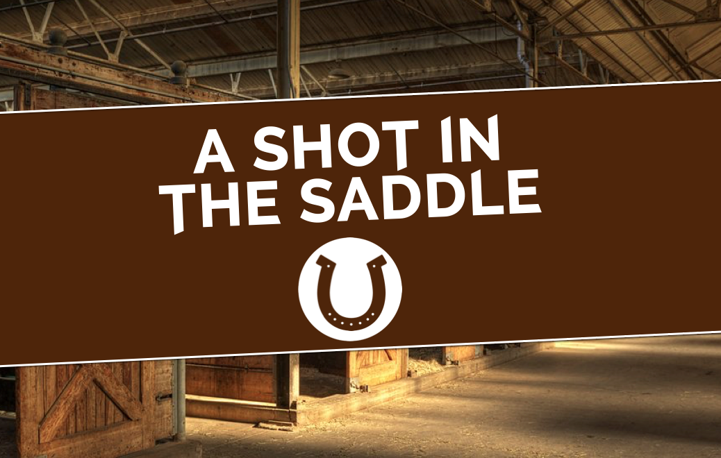

#WHOKILLEDGIDEONUPP
PLAYERS TAKE THE REINS TO CATCH READING KILLER
IN SINISTER LIVE-ACTION MURDER MYSTERY
TREASURE HUNT THIS SPRING

Saturday 28th April, Saturday 5th May & Saturday 12th May.
Running at 12pm and 3pm. Tickets £20 from www.ashotinthesaddle.com

The team behind A Dish To Die For and A Melody For Murder are back with their most sinister mystery yet. A Shot In The Saddle is a brand new, 3 hour, immersive Murder Mystery Treasure Hunt that challenges the public to take the reins and race round Reading to hunt down hidden evidence and catch a killer in their tracks as they crack the case of #WhoKilledGideonUpp – against the clock!

The whole town becomes the set for this real-life whodunnit, which fuses live-action, escape-room style puzzles, a scavenger hunt and actors with a murder mystery, as players must crack cryptic clues using their smartphones, converse with suspicious characters and find vital evidence hidden around the town, in partnership with local businesses and iconic Reading locations!

The game centres around the murder of world-famous racehorse trainer Gideon Upp. Gideon was staying in Reading before taking his prized horse to the races but he never reached the final furlong. Last night, someone snuck into his hotel room and shot him at point blank range. But the only fingerprints found on the pistol were Gideon’s. Scotland Yard just canter work it out – and they need your help.

Returning with their unique mystery concept for Reading, creators Richard Alexander and Alex Farthing are promising A Shot In The Saddle will be their most sinister mystery yet. On average, players walk 3.2 miles around the town to crack the case – discovering hidden gems and exploring Reading’s history along the way. Perfect for friends and families, teams or individuals, detectives who have taken part have collectively discovered over 89 clues in 51 locations, racking up over 500 sleuthing hours combined; an impressive feat!

A Shot In The Saddle runs at 12pm and 3pm on Saturday 28th April, Saturday 5th May & Saturday 12th May. Tickets are £20 from www.ashotinthesaddle.com. Find us on all social media using #WhoKilledGideonUpp.

-ENDS-

For further details please contact Richard or Alex on press@ashotinthesaddle.com

