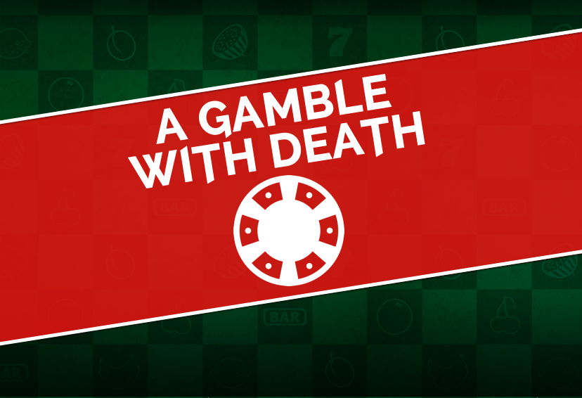

#WHOKILLEDJACKDIAMOND
PLAYERS RACE AROUND READING TO FIND
HIDDEN CLUES IN LIVE-ACTION MURDER MYSTERY
TREASURE HUNT THIS SUMMER

Saturday 22nd July, Saturday 29th July and Saturday 5th August.
Running at 12pm and 3pm. Tickets £20 from www.agamblewithdeath.com

This Summer sees a brand new live-action interactive adventure for families, colleagues and friends. Using their smartphones, players must race around the streets of Reading to find hidden evidence, crack cryptic clues and converse with suspicious-looking characters to catch the culprit – before the time runs out.

A Gamble With Death is 3-hour live-action treasure hunt with a difference. Imagine the crystal maze, some escape room puzzles, a scavenger hunt, a team of live actors, your smartphone and a murder mystery all got together - with a timer. Local businesses and iconic Reading locations are in on the action too, with clues hidden all around the Town Centre.

This new concept sees players working as solo sleuths or as teams of intrepid detectives searching the streets of Reading against the clock, and uniquely allows them to discover hidden gems around the town, explore Reading's history and crack the case in an intriguing new way.​

The game centres around the Abbey Ruins, which aren’t being restored at all – but are being demolished by notorious businessman, Jack Diamond, to make way for The Golden Abbey Casino. The plans for the Casino were passed but certain individuals weren’t happy, and last night - his luck ran out.

A Gamble With Death runs at 12pm and 3pm on Saturday 22nd & 29th July and Saturday 5th August. Tickets are £20 from www.agamblewithdeath.com. On social media, find us using #WhoKilledJackDiamond

-ENDS-

For further details please contact Richard or Alex on press@agamblewithdeath.com or tweet us @agamblewith

